Neha Waikar
PYTHON PROGRAMMING
DATE OF PERFORMANCE : 20/09/24
PRACTICAL 4B
1. Create a tuple with only one element “JAVA” in it.
Input:
a =("java",)
print(a)
Output:
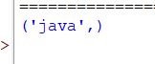

2. Given a list a=[22,33,44,55], convert it into a tuple.
Input:
a=[22,33,44,55]
b=tuple(a)
print(b)
Output:
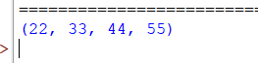

3. Write a program to create a tuple of five numbers which are to be
taken from the user.
Input:
num=input("Enter 5 numbers separated by spaces:")
list=(int(num) for num in num.split())
a=tuple(list)
print("Tuple:",a)
Output:
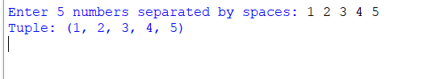
4. Given a tuple b=(23,43,67,88,123) write the code to find the sum
of every 2nd element.
Input:
b=(23,43,67,88,123)
a=b[1::2]
c=sum(a)
print("Sum of every 2nd element:",c)
Output:
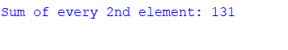
5. Given a tuple m=(“Zero”,”One”,”Two”,”Three”,”Four”,”Five”), display
the length, maximum and minimum value
Input:
m=('Zero','One','Two','Three','Four','Five')
a=min(m)
b=max(m)
c=len(m)
print("Maximum value:",a)
print("Minimum value:",b)
print("Length:",m)
Output:
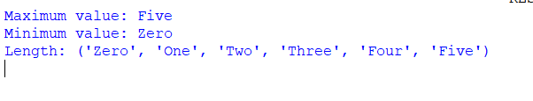
6.Given a tuple c=(45,34,23,12,24,35), display the sum and average of
all the elements.
Input:
c=(45,34,23,12,24,35)
a=sum(c)
b=a/len(c)
print("Sum of tuple:",a)
print("Average of tuple:",b)
Output:
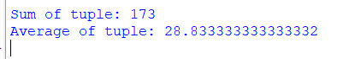
7.Delete tuple c.
Input:
c=(45,34,23,12,24,35)
del(c)
print(c)
Output:
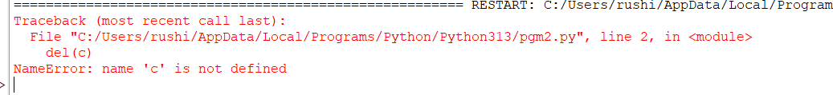
8. Given b=(23,43,67,88,[87,65],123), write the code to change 87 to 92.
Input:
b=(23,43,67,88,[87,65],123)
b[4][0]=92
print(b)
Output:
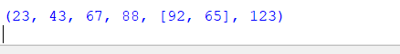
9. From the tuple ‘m’, write the code to display output as ‘our’.
Input:
m=('Zero','One','Two','Three','Four','Five')
b=m[4][1:4]
print(b)
Output:
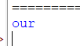

10. Display the tuple m after sorting in the reverse order.
Input:
m=('Zero','One','Two','Three','Four','Five')
sorted_m=tuple(sorted(m,reverse=True))
print(sorted_m)
Output:
